考勤督查操作手册-学生版
Attendance Inspection Operation Manual - Student Edition

手机端
Mobile App

1.查看个人课表

View Personal Schedule
登录手机学习通APP，点击首页选择浙江师范大学，下拉查看学生个人课表。课表页面会根据教务系统的排选课情况，以课表结构显示学生的上课详情
Open the Xuexitong app, click “Home Page”, select Zhejiang Normal University (浙江师范大学), and scroll down to view your personal class schedule. The schedule displays course details based on academic system data.
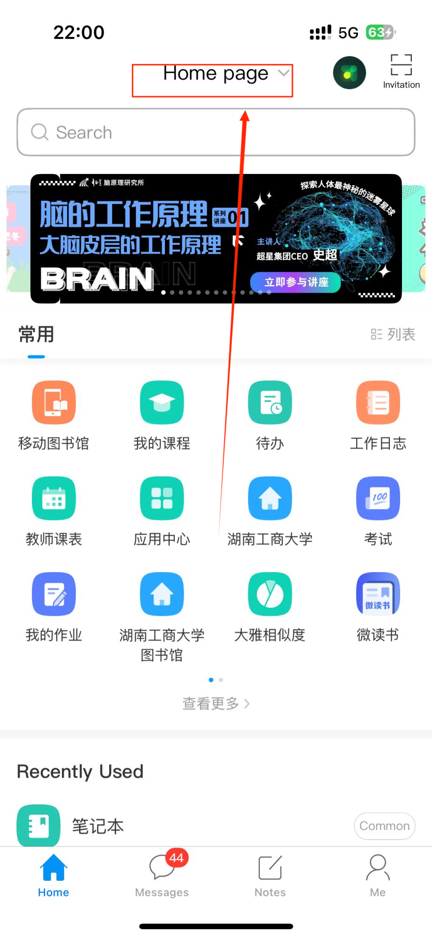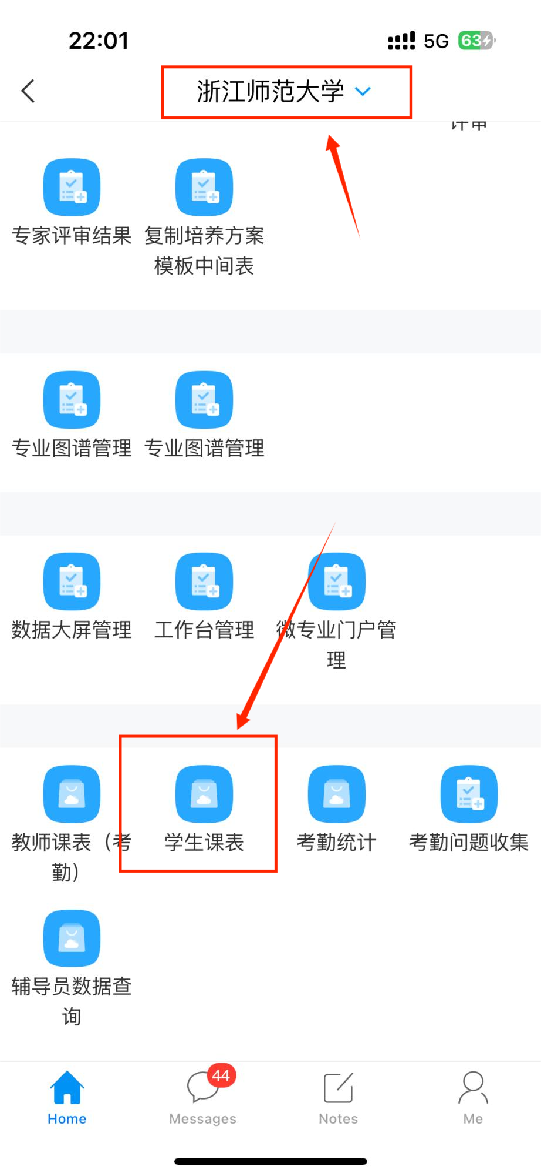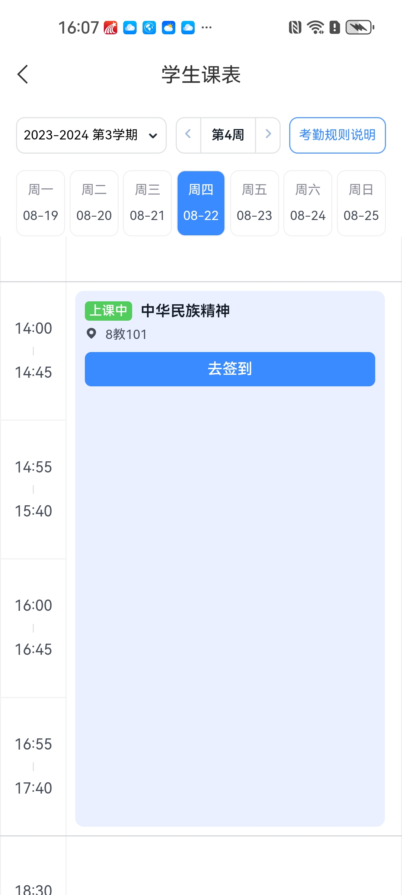

2.去签到

Check In
授课教师发起签到后，学生在学习通中会收到弹框提示（学习通内消息推送需要保持学习通激活），同时在课表页面，会出现“去签到”按钮（学生可以在课表页面下拉刷新获取），若学生账号绑定并关注了学习通微信公众号，系统会同步将签到通知推送到微信公众号消息中。
When the teacher initiates check-in, students will receive a pop-up notification (keep Xuexitong active to receive push notifications). A "Go to Check-in" button will appear on the schedule page (refresh the page if needed). If your account is linked to the Xuexitong WeChat official account, the notification will also be sent via WeChat.
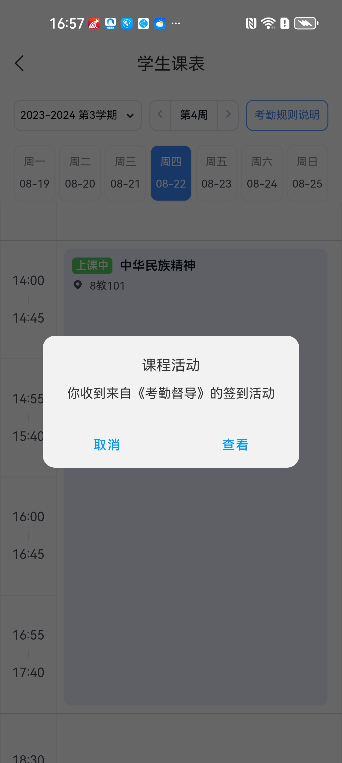 | 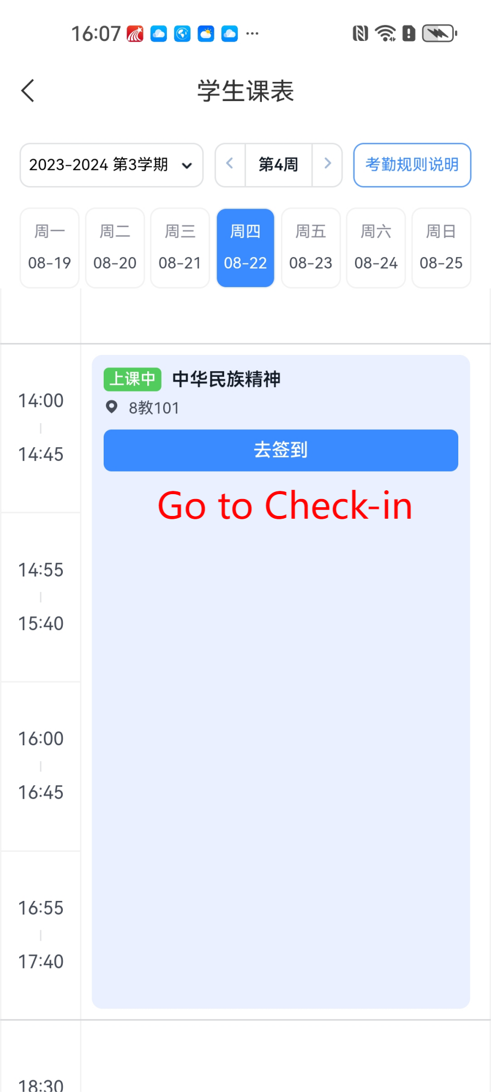
点【去签到】后，需要按指示操作后即可完成签到，此时签到状态为【已签】。若点开签到的时间已结束，但是还在有效时间范围内，此时的签到状态为【迟到】。
Click "Go to Check-in" and follow the instructions. The status will then show "Checked in". If you open the check-in after the time limit has ended but still within the valid time range, the status will show "Late".
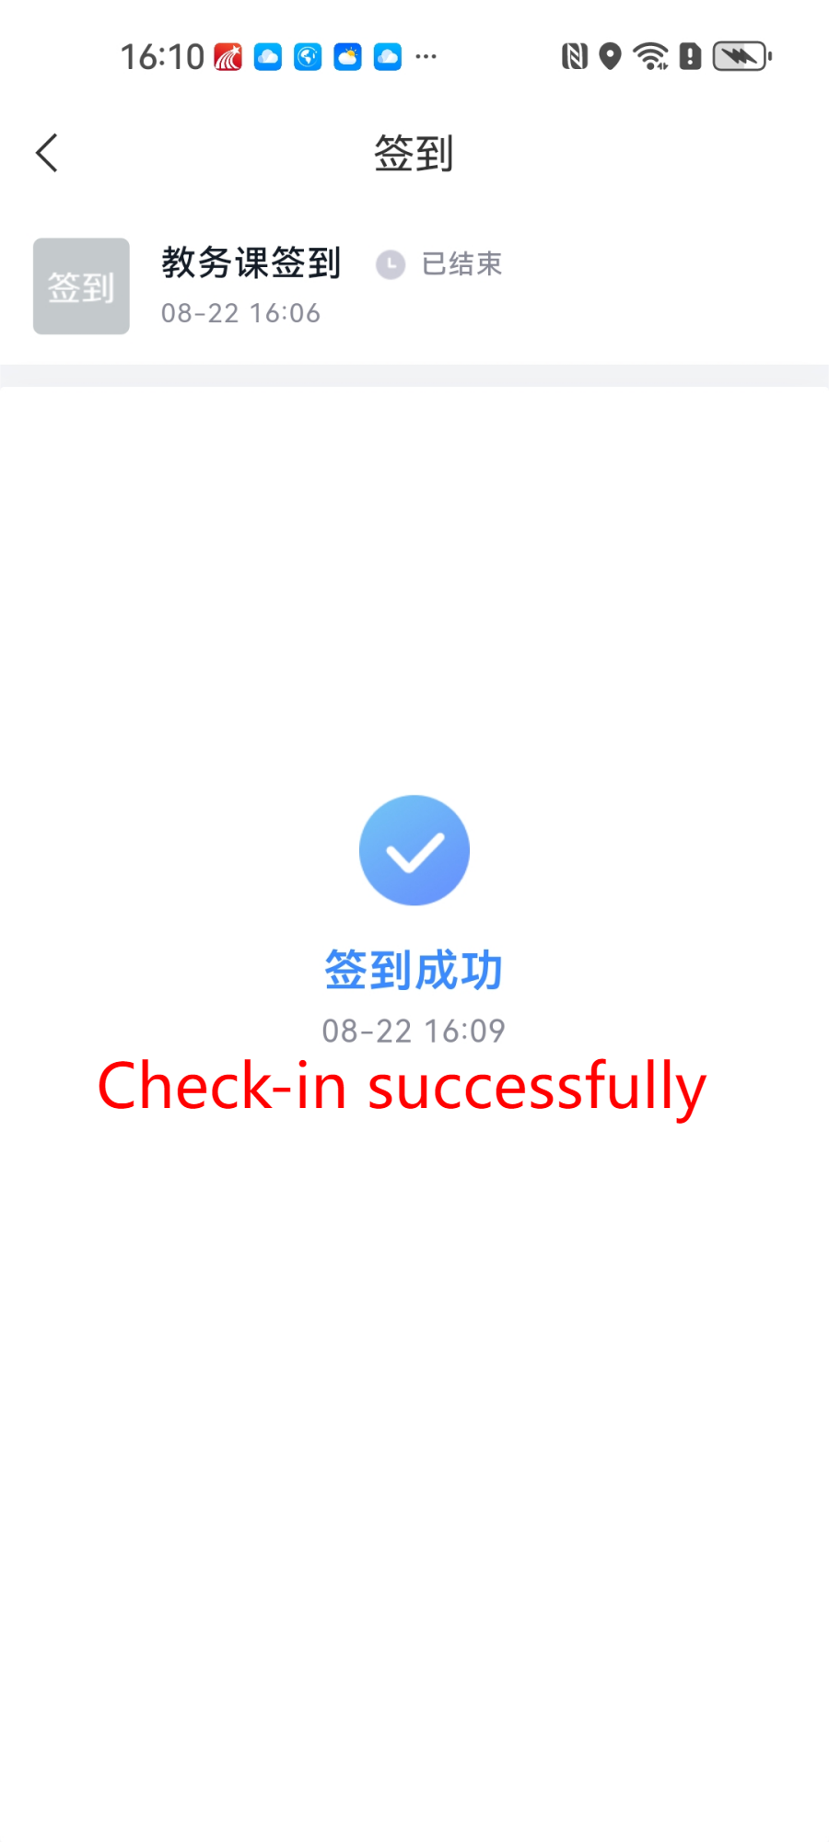

3.查看课堂详情

View class details
点击课表课程，可以在详情页中查看课堂详情信息和本堂课中教师发起的签到
Tap a course on the schedule to view class details and check-in records for that session.

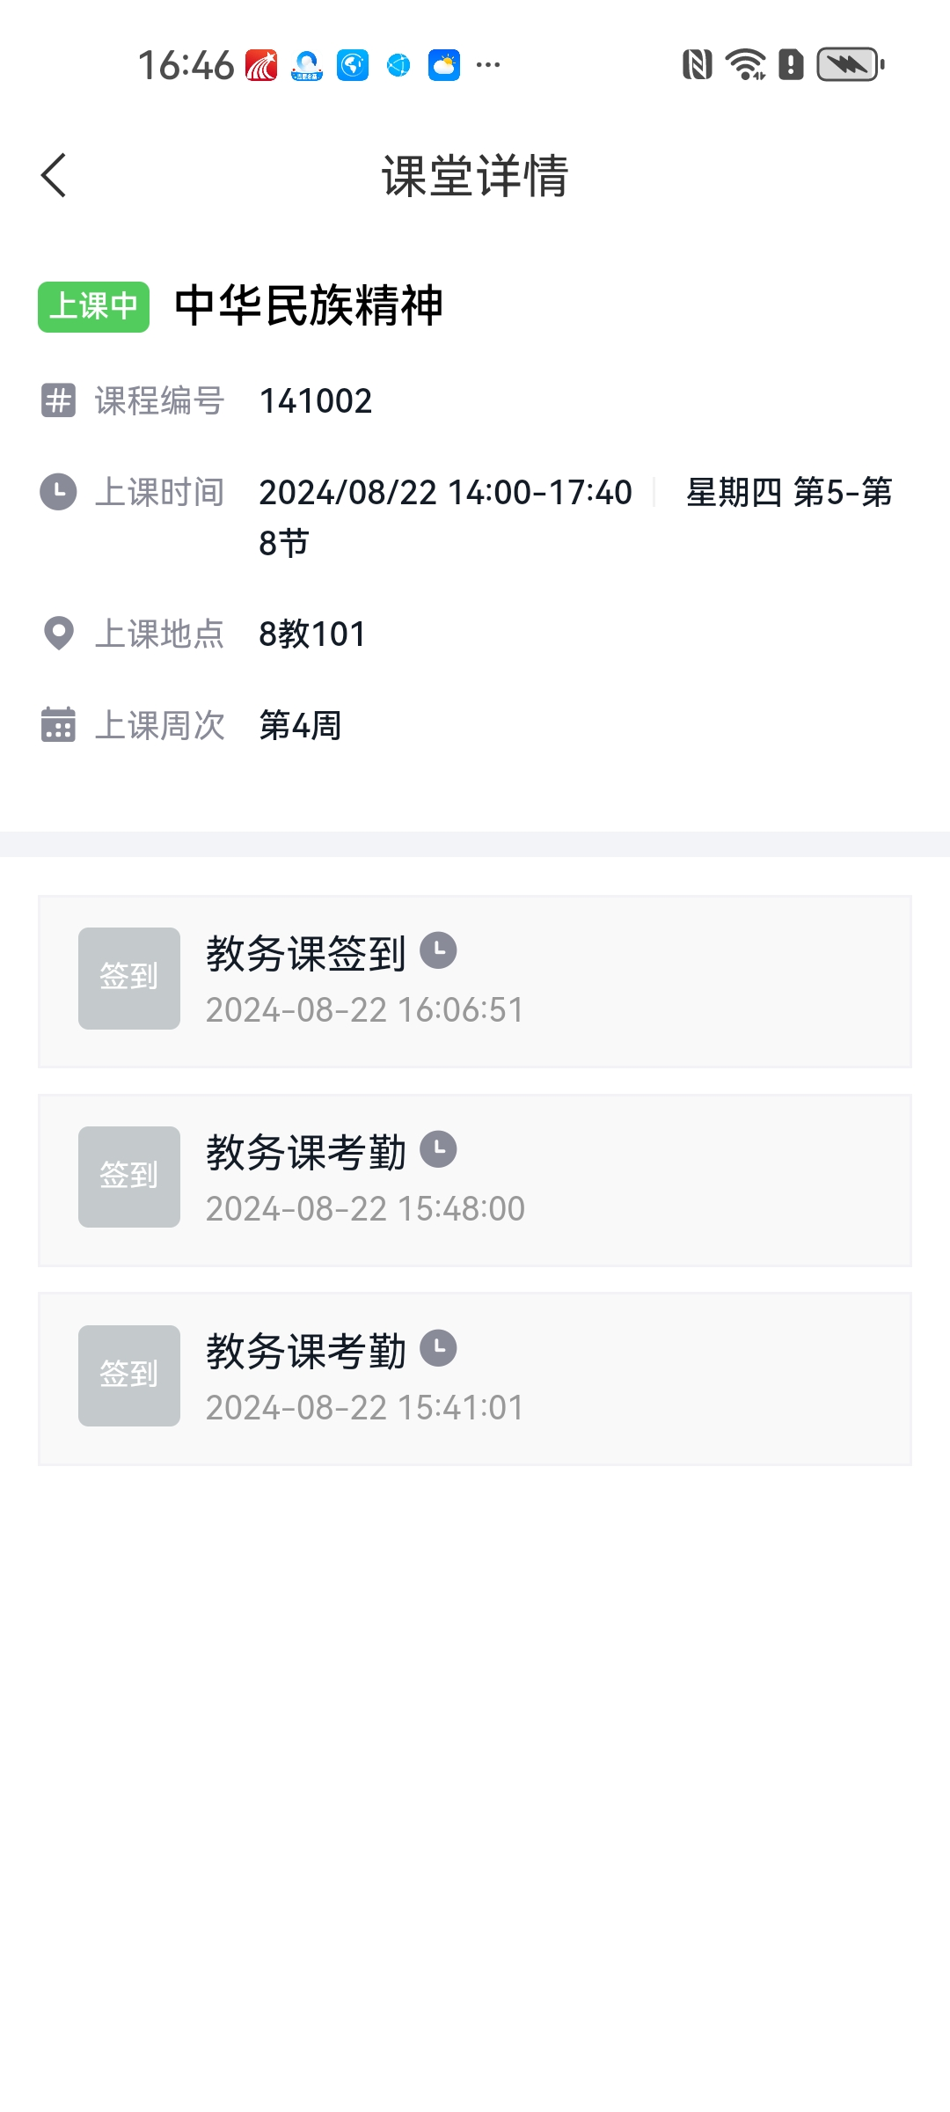

4.查看考勤统计规则

View Attendance Rules
点击页面右上角按钮，支持查学校考勤统计规则
Click the button in the top-right to view the school's attendance statistics rules.
